

ASSIGNMENT 1
PROGRAMMING TECHNIQUE I
(SECJ1013)

NAME | MATRIC NUMBER
MUHAMMAD AFIQ DANIAL BIN ROZAIDIE | A23CS0117
MOHAMED ALIF FATHI BIN ABDUL LATIF | A23CS0112

Lecturer: Dr. Nies Hui Wen

SET 1

1. Start
2. Read name1, matric1, name2, matric2
3. display “Assignment 1”
4. display “Course: SECJ 1013 Programming Technique 1”
5. display “Section 03”
6. display “Program: Bachelor of Computer Science (Data Engineering)”
7. display “Member”
8. display name1, “(“, matric1, “)”
9. display name2, “(“, matric2, “)”
10. End

# include <iostream>
using namespace std;

int main(){

string name1, name2, matric1, matric2;

cout << "Enter member 1 name: ";
cin >> name1;
cout << "Enter member 1 matric number: ";
cin >> matric1;
cout << "Enter member 2 name: ";
cin >> name2;
cout << "Enter member 2 matric number: ";
cin >> matric2;

cout << "\nAssignment 1\n-----------------\nCourse: SECJ 1013 Programming Technique 1" << endl;
cout << "Section: 03\nProgram: Bachelor of Computer Science(Data Engineering)" << endl;
cout << "Member:\n" << name1 << " (" << matric1 << ")" << endl;
cout << name2 << " (" << matric2 << ")" << endl;

return 0;
}

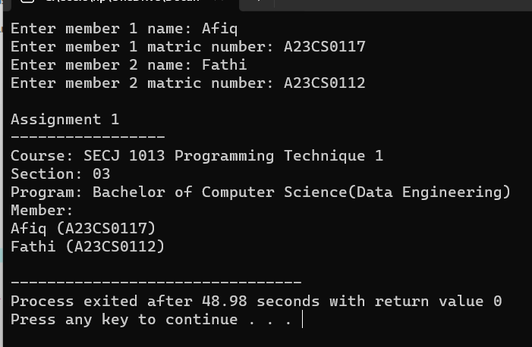
OUTPUT:
SET 4
# include <iostream>
using namespace std;

int main (){
double price;
int quantity;
string level;
price = 0;
cout << "Enter the quantity and level: ";
cin >> quantity >> level;

if (level == "Low"){
if (quantity >= 0 && quantity < 15)
price = quantity * 0.3;
else if (quantity >= 15 && quantity <= 50)
price = quantity * 0.5;
else if (quantity >= 51)
price = quantity * 0.7;}

else{
if (quantity > 0 && quantity <= 10)
price = quantity * 0.2;
else if (quantity > 10 && quantity <= 20)
price = quantity * 0.3;
else if (quantity > 20)
price = quantity * 0.6;}

cout << "Price: RM " << price ;
return 0;
}

OUTPUT 1:
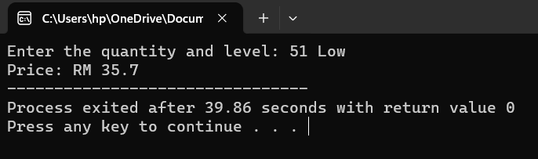
OUTPUT 2:
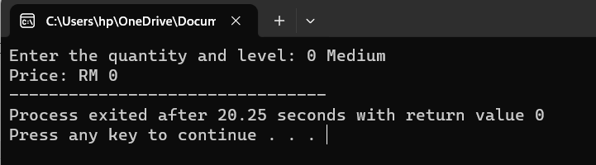
OUTPUT 3:
